**Wordpress application deployment using Terraform**

**Architecture Diagram**

The 3-tier architecture used in this project consists of a web layer, an application layer, and a database layer. The infrastructure is provisioned using Terraform and consists of several components, including a VPC, subnets, security groups, EC2 instances, an RDS instance, an EFS file system, and an ALB. These components are configured to work together to provide a scalable and highly available infrastructure for hosting the WordPress application.

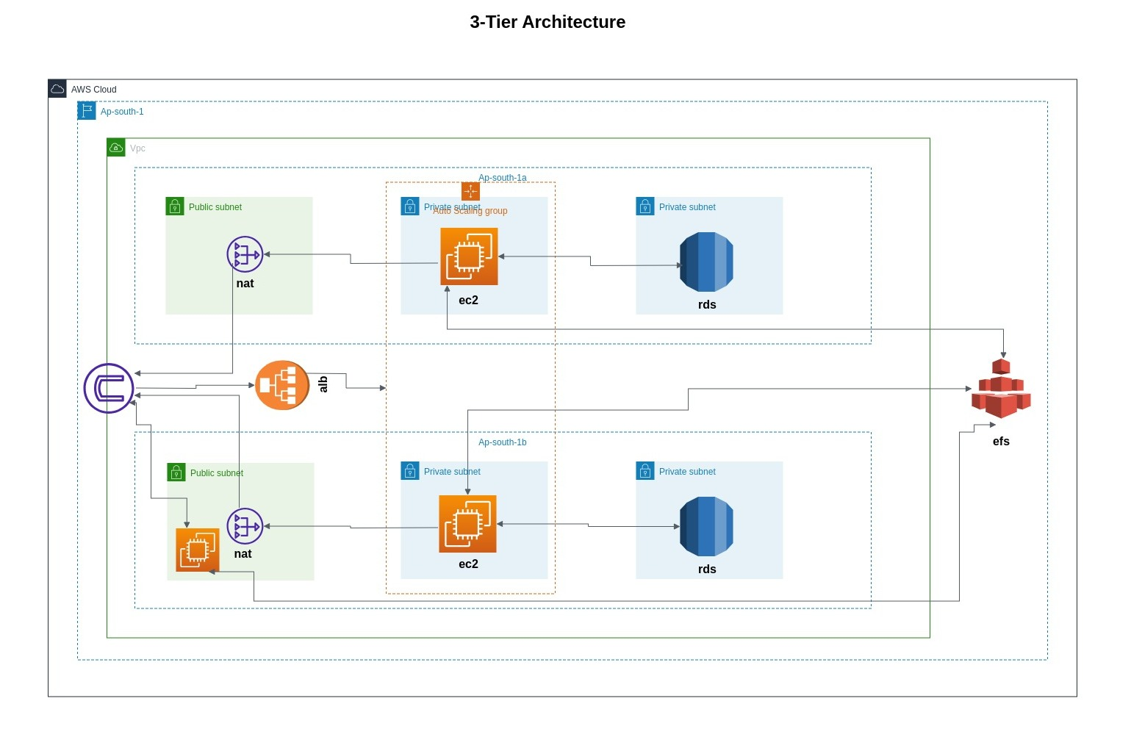

**AWS Services**

This project uses several AWS services to provision the infrastructure for hosting a WordPress application using a 3-tier architecture. The following AWS services are used:

* **Amazon VPC**: Used to create a virtual private cloud (VPC) for the infrastructure.
* **Amazon EC2**: Used to launch EC2 instances for the web and application layers.
* **Amazon RDS**: Used to create an RDS instance for the database layer.
* **Amazon EFS** Used to create an Elastic File System (EFS) for storing WordPress files.
* **Amazon ALB** Used to create an Application Load Balancer (ALB) for distributing traffic between the web and application layers.
* **Amazon CloudWatch** Used to monitor the infrastructure and collect logs and metrics.

## Usage

1. Navigate to the project directory: cd wp-3tier-aws/src/infrastructure/

Main.tf

module "vpc_module" {

  source = "./modules/vpc"

}

module "subnet_module" {

  source   = "./modules/subnets"

  vpc_id   = module.vpc_module.vpc_id

  zone_one = var.zone_one

  zone_two = var.zone_two

}

module "internet_gateway_module" {

  source = "./modules/internet-gateway"

  vpc_id = module.vpc_module.vpc_id

}

module "nat_gateway_module" {

  source     = "./modules/nat-gateway"

  subnet_ids = module.subnet_module.subnet_ids

}

module "route_module" {

  source              = "./modules/route-table"

  subnet_ids          = module.subnet_module.subnet_ids

  nat_ids             = module.nat_gateway_module.nat_ids

  vpc_id              = module.vpc_module.vpc_id

  internet_gateway_id = module.internet_gateway_module.igw_id

}

module "security_group_module" {

  source = "./modules/security-groups"

  vpc_id = module.vpc_module.vpc_id

  my_ip  = var.my_ip

}

module "s3_bucket" {

  source = "terraform-aws-modules/s3-bucket/aws"

  bucket = "my-s3-bucket"

  acl    = "private"

  control_object_ownership = true

  object_ownership         = "ObjectWriter"

  versioning = {

    enabled = true

  }

}

module "database_module" {

  source     = "./modules/database"

  subnet_ids = module.subnet_module.subnet_ids

  db_sg_id   = module.security_group_module.db_sg_id

}

module "efs_module" {

  source     = "./modules/efs"

  efs_sg_id  = module.security_group_module.efs_sg_id

  subnet_ids = module.subnet_module.subnet_ids

}

module "ec2_module" {

  source = "./modules/ec2"

  efs_sg_id        = module.security_group_module.efs_sg_id

  ssh_sg_id        = module.security_group_module.ssh_sg_id

  lb_sg_id         = module.security_group_module.lb_sg_id

  wb_sg_id         = module.security_group_module.wb_sg_id

  db_sg_id         = module.security_group_module.db_sg_id

  subnet_ids       = module.subnet_module.subnet_ids

  wordpress_tg_arn = module.alb_module.wordpress_tg_arn

  efs_dns_name     = module.efs_module.efs_dns_name

  db               = module.database_module.db

}

module "alb_module" {

  source          = "./modules/load-balancer"

  vpc_id          = module.vpc_module.vpc_id

  lb_sg_id        = module.security_group_module.lb_sg_id

  subnet_ids      = module.subnet_module.subnet_ids

  auto_scaling_id = module.ec2_module.auto_scaling_id

}

module "cloud_watch_module" {

  source            = "./modules/cloud-watch"

  auto_scaling_name = module.ec2_module.auto_scaling_name

}

Variable.tf

variable "region" {

  type = string

}

variable "config" {

  type    = string

  default = "~/.aws/config"

}

variable "credentials" {

  type    = string

  default = "~/.aws/credentials"

}

variable "my_ip" {

  description = "ip address"

  type        = string

}

variable "zone_one" {

  description = "region"

  type        = string

}

variable "zone_two" {

  description = "region"

  type        = string

}

Provider.tf

terraform {

  required_providers {

    aws = {

      source = "hashicorp/aws"

    }

  }

}

provider "aws" {

  region                   = var.region

  shared_config_files      = [var.config]

  shared_credentials_files = [var.credentials]

}

Terraform.tfvars

my_ip  = "35.170.239.160"

region = "us-east-1"

zone_one = "us-east-1a"

zone_two = "us-east-1b"

1. Initialize Terraform: terraform init -var-file = “terraform.tfvars”
2. Create a terraform.tfvars file with your AWS credentials and other required variables.
3. Terraform plan -var-file = “terraform.tfvars”
4. Terraform apply -var-file= “terraform.tfvars”

Resources has been provisioned successfully

This terraform code supports multiple regions in the terraform.tfvars we can choose any region based on the input it will be provision .

**Output**

